**EXP NO: 4a**

**TITLE:Conduct task analysis for an app (e.g., online shopping) and**

**document user flows. Create corresponding wireframes using Lucid chart**

**AIM:**

To understand and document the steps a user takes to complete the main tasks within an online shopping app.

**Procedure:**

1. Create a New Document – Sign in to Lucidchart, click *Create New Diagram*.
2. Select a Template – Choose a blank document or a flowchart template.
3. Add Shapes – Drag rectangles for actions, diamonds for decisions, and ovals for start/end points.
4. Connect Shapes – Use arrows to show the sequence of steps.
5. Label Steps – Add text inside shapes describing each user action.
6. Customize Flowchart – Use colors, align elements, and group steps logically.
7. Review & Save – Ensure correctness, click *File → Save*.
8. Share & Export – Click *Share* for collaboration or export as an image/PDF.

**OUTPUT:**

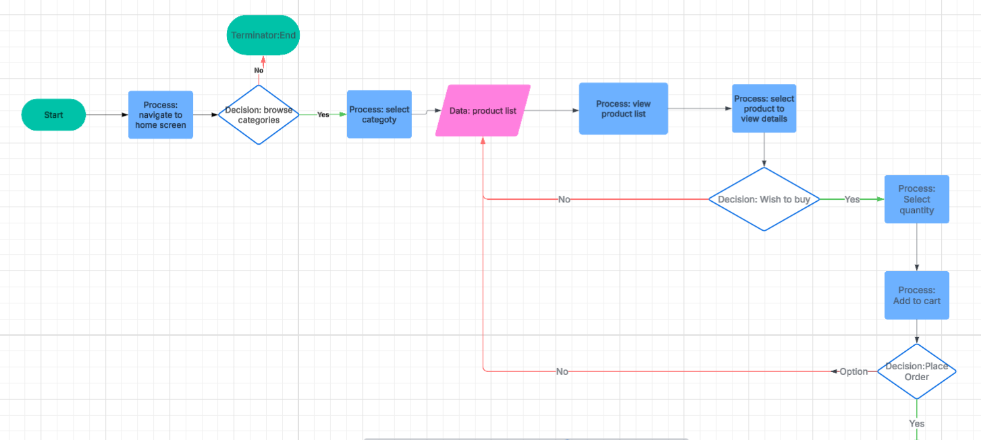

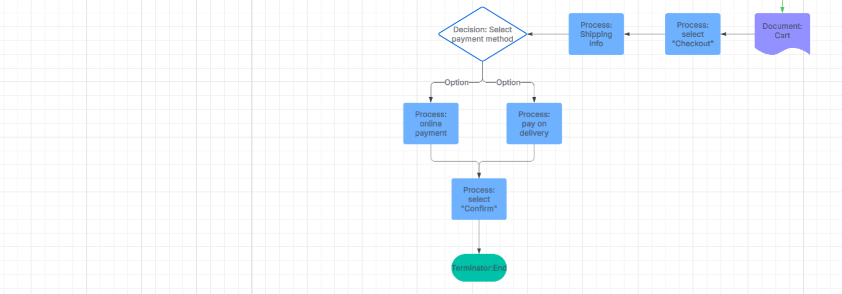

**Result:** A structured flowchart visualizing user flows for browsing, searching, adding to cart, checkout, and order tracking.

**LINK:** https://lucid.app/lucidchart/f048c719-a6e3-42d4-bfac-ca40f11ded49/edit?invitationId=inv_d520bc66-0f6b-4ce4-9626-4e892ac49207